**Kirtan Circle Santa Cruz**

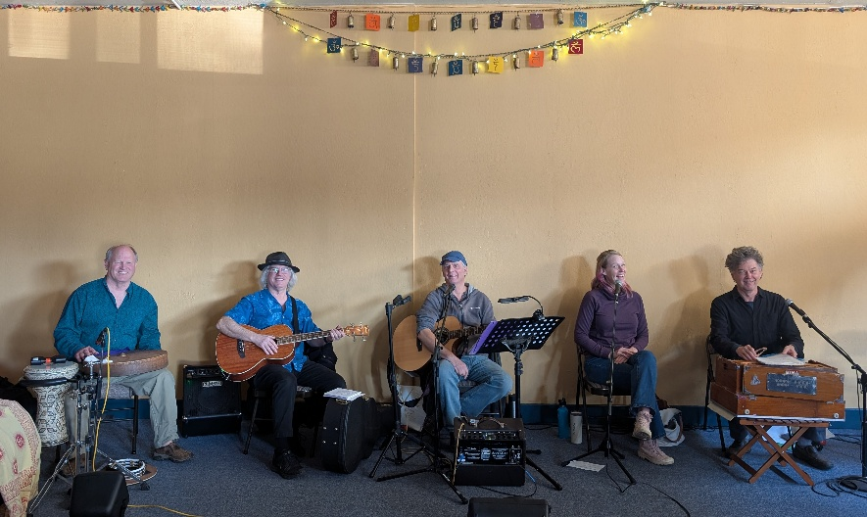

Every 2nd Sunday   5:30 – 7:30pm

Next one May 11th

Center for Healing, 6144 Hwy 9, Felton 

For more info see: <https://www.santacruzkirtan.org>

**Join us in chanting the sacred Names! This is an ongoing celebration of sacred chant with our extended Bhakti community.**

**Let's dive into the sacred sound together.**

**Suggested donation $10-$20**

**David Rhodes, co-founder of the Kirtan Circle Santa Cruz has been leading Kirtan for 20 years. He is a classically trained pianist and a composer and recording artist.**

